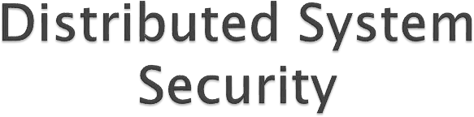

Security Threats

Security Policy

Security Mechanisms

Globus Security Architecture



way of looking at security in computer

systems is that we attempt to protect the

services and data it offers against security

threats

There are four types of security threats

1. Interception

2. Interruption

3. Modification

4. Fabrication



The concept of interception refers to the

situation that an unauthorized party has

gained access to a service or data

◦ Example

Where communication between two parties has been

overheard by someone else

Interception also happens when data are illegally copied

◦ Example

after breaking into a person's private directory in a file system.



An example of interruption is when a file is

corrupted or lost.

More generally interruption refers to the situation in which services or data become unavailable, unusable, destroyed, and so on.

◦ Example

denial of service attacks by which someone maliciously attempts to make a service inaccessible to other parties is a security threat that classifies as interruption



involve unauthorized changing of data or

tampering with a service so that it no longer

adheres to its original specifications

Example

◦ Modifications include intercepting and subsequently changing transmitted data, tampering with database entries, and changing a program so that it secretly logs the activities of its user.



Refers to the situation in which additional data or activity are generated that would normally not exist.

Example

◦ an intruder may attempt to add an entry into a password file or database. Likewise, it is sometimes possible to break into a system by replaying previously sent messages

Note that interruption, modification, and fabrication can each be seen as a form of data falsification



Simply stating that a system should be able

to protect itself against all possible security

threats is not the way to actually build a

secure system.

What is first needed is a description of security requirements, that is, a security policy.



A security policy describes precisely which

actions the entities in a system are allowed to

take and which ones are prohibited. Entities

include users, services, data, machines, and

so on.

Once a security policy has been laid down, it becomes possible to concentrate on the security mechanisms by which a policy can be enforced.



Important security mechanisms are :

1. Encryption

2. Authentication

3. Authorization

4. Auditing



Encryption is fundamental to computer

security

Encryption transforms data into something an attacker cannot understand.

In other words

◦ encryption provides a means to implement data confidentiality.

In addition, encryption allows us to check

whether data have been modified.

It thus also provides support for integrity checks.



is used to verify the claimed identity of a

user, client, server, host, or other entity.

In the case of clients, the basic premise is that before a service starts to perform any work on behalf of a client, the service must learn the client's identity (unless the service is available to all).

Typically, users are authenticated by means of passwords, but there are many other ways to authenticate clients.



After a client has been authenticated, it is

necessary to check whether that client is

authorized to perform the action requested

Example

◦ Access to records in a medical database

Depending on who accesses the database.

Permission may be granted to read records, to

modify certain fields in a record, or to add or

remove a record



Auditing tools are used to trace which clients

accessed what, and which way.

Although auditing does not really provide any protection against security threats.

Audit logs can be extremely useful for the analysis of a security breach, and subsequently taking measures against intruders.



For this reason, attackers are generally keen

not to leave any traces that could eventually

lead to exposing their identity.

In this sense, logging accesses makes

attacking sometimes a riskier business.



|  |  |  |  |
| --- | --- | --- | --- |
| To devise | and | properly | use security |
| mechanisms, | it is | necessary | to understand |

what exactly needs to be protected, and what

the assumptions are with respect to security.

security policy for Globus entails eight

statements



|  |  |  |  |
| --- | --- | --- | --- |
|  | Globus | assumes | that the environment |
|  | consists | of multiple | administrative domains, |

where each domain has its own local security

policy.

It is assumed that local policies cannot be changed just because the domain participates in Globus, nor can the overall policy of Globus override local security decisions.

Consequently, security in Globus will restrict itself to operations that affect multiple domains



operations that are initiated and carried out

only within a single domain

all security issues will be carried out using local security measures only.

Globus will not impose additional measures

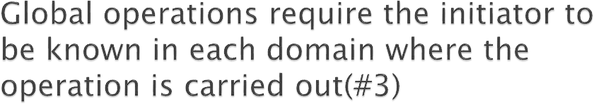

The Globus security policy states that

requests for operations can be initiated either

globally or locally.

The initiator, be it a user or process acting on behalf of a user, must be locally known within each domain where that operation is carried out.

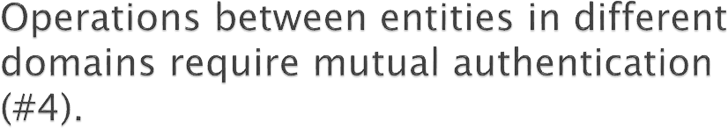

An important policy statement is that

operations between entities in different

domains require mutual authentication.

for example,

◦ that if a user in one domain makes use of a service from another domain, then the identity of the user will have to be verified.



If the identity of a user has been verified, and

that user is also known locally in a domain,

then he can act as being authenticated for

that local domain.

This means that Globus requires that its system wide authentication measures are sufficient to consider that a user has already been authenticated for a remote domain when accessing resources in that domain.

Additional authentication by that domain



Once a user has been authenticated, it is still

necessary to verify the exact access rights

with respect to resources.

For example,

◦ a user wanting to modify a file will first have to be authenticated, after which it can be checked whether or not that user is actually permitted to modify the file.



consider a mobile agent in Globus that carries

out a task by initiating several operations in

different domains, one after another. Such an

agent may take a long time to complete its

task.

To avoid having to communicate with the user on whose behalf the agent is acting, Globus requires that processes can be delegated a subset of the user's rights.

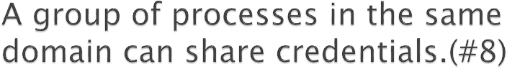

Globus requires that groups of processes

running with a single domain and acting on

behalf of the same user may share a single

set of credentials.

credentials are needed for authentication.

This statement essentially opens the road to scalable solutions for authentication by not demanding that each process carries its own unique set of credentials.



Globus architecture is described using entities:

◦ Users

◦ User proxies: processes that are given permission to act on behalf of a user temporarily.

◦ Resource proxies: processes used to translate a remote user’s requests into operations that do not violate a resource’s local security policy.

◦ General processes

The globus security architecture defines four

different protocols,

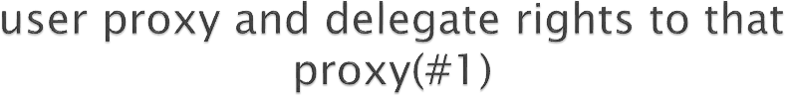

in order to let the user proxy act on behalf of

its user, the user gives the proxy an

appropriate set of credentials

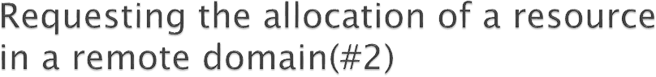

the protocol tells a resource proxy to create a

process in the remote domain after mutual

authentication has taken place.

|  |  |  |  |
| --- | --- | --- | --- |
| That process | represents | the user, | but |
| operates in | the same | domain as | the |

requested resource.

The process is given access to the resource subject to the access control decisions local to that domain.



In the Globus system, this type of allocation

is done via the user proxy, by letting a

process have its associated user proxy

request the allocation of resources,

essentially following the second protocol.



Assuming that a user has an account in a

domain, what needs to be established is that

the system wide credentials as held by a user

proxy are automatically converted to

credentials that are recognized by the specific

domain.

The protocol prescribes how the mapping between the global credentials and the local ones can be registered by the user in a mapping table local to that domain.

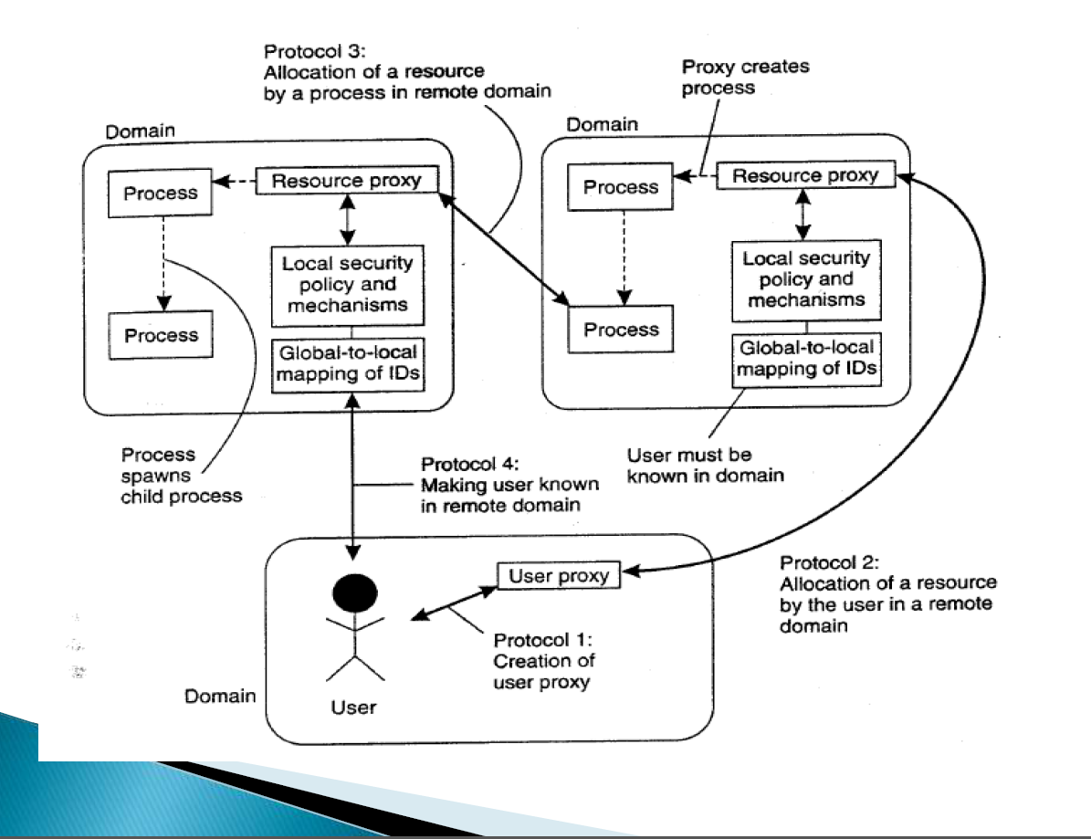



Andrew S.Tanenbaum & Maarten Van Steen.

Distributed Systems – Principles and

Paradigms. 2nd ed. 2007.